**Experiment No. 1**

**Code:**

**1. TCP**

**Server.java**

import java.util.*;

import java.io.*;

import java.net.*;

public class Server {

public static void main(String args[]) throws Exception{

//Server server = new Server();

ServerSocket MyServer = new ServerSocket(25);

Socket ss = MyServer.accept();

DataInputStream din =new DataInputStream(ss.getInputStream());

DataOutputStream dout=new DataOutputStream(ss.getOutputStream());

BufferedReader br=new BufferedReader(new InputStreamReader(System.in));

Server server = new Server();

String str="",str2="";

int sum = 0;

while(!str.equals("stop")){

str=din.readUTF();

if(str.equals("stop"))

break;

sum = sum + Integer.parseInt(str);

}

dout.writeUTF(Integer.toString(sum));

dout.flush();

din.close();

ss.close();

MyServer.close();

}

}

**Client.java**

import java.io.*;

import java.util.*;

import java.net.*;

public class Client

{

public static void main(String args[])throws Exception

{

String send="",r="";

Socket MyClient = new Socket("192.168.0.106",25);

DataInputStream din=new DataInputStream(MyClient.getInputStream());

DataOutputStream dout = new DataOutputStream(MyClient.getOutputStream());

Scanner sc = new Scanner(System.in);

while(!send.equals("stop")){

System.out.print("Send: ");

send = sc.nextLine();

dout.writeUTF(send);

}

dout.flush();

r=din.readUTF();

System.out.println("Reply: "+ r);

dout.close();

din.close();

MyClient.close();

}

}

**Output:**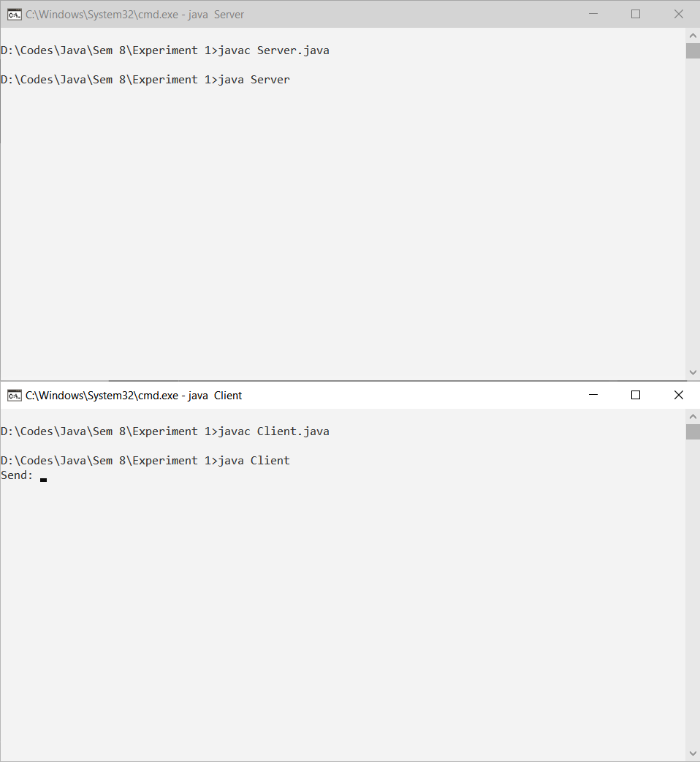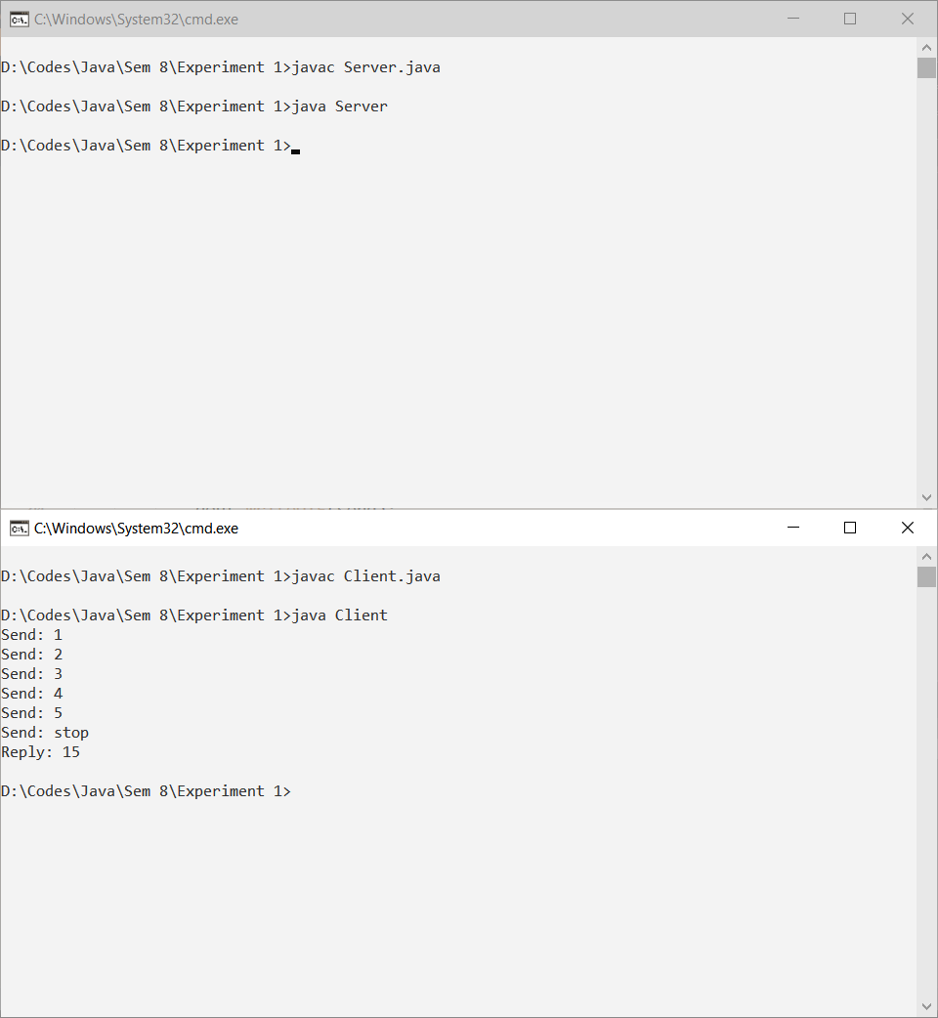

**2. UDP**

**Server.java**

import java.util.*;

import java.io.*;

import java.net.*;

public class Server {

public static void main(String args[]) throws Exception{

DatagramSocket ds = new DatagramSocket(1234); //Receive

DatagramSocket ds1 = new DatagramSocket(); //Send

byte[] receive = new byte[65535];

byte[] send = new byte[65535];

Scanner sc = new Scanner(System.in);

String str1 = new String();

DatagramPacket DpReceive = null;

DatagramPacket DpSend = null;

InetAddress inet;

while (true) {

DpReceive = new DatagramPacket(receive, receive.length);

ds.receive(DpReceive);

System.out.println("Client:-" + new String(DpReceive.getData(), 0, DpReceive.getLength() ));

if (data(receive).toString().equals("stop")) {

break;

}

str1 = sc.nextLine();

send = str1.getBytes();

inet = InetAddress.getByName("225.4.5.6");

DpSend = new DatagramPacket(send, send.length, inet, 1234);

ds1.send(DpSend);

receive = new byte[65535];

}

}

public static StringBuilder data(byte[] a)

{

if (a == null)

return null;

StringBuilder ret = new StringBuilder();

int i = 0;

while (a[i] != 0)

{

ret.append((char) a[i]);

i++;

}

return ret;

}

}

**Client.java**

import java.io.*;

import java.util.*;

import java.net.*;

public class Client{

public static void main(String args[])throws Exception {

String send="",r="";

DatagramSocket ds = new DatagramSocket();

InetAddress ip = InetAddress.getByName("192.168.0.106");

byte buf[] = null;

Scanner sc = new Scanner(System.in);

while(!send.equals("stop")) {

System.out.print("Send: ");

send = sc.nextLine();

buf = send.getBytes();

DatagramPacket DpSend = new DatagramPacket(buf, buf.length, ip, 1234);

ds.send(DpSend);

}

}

}

**Output**

